Instruction Manual

SD PLOTTER DB®
Version 3.0

Ver 3.0

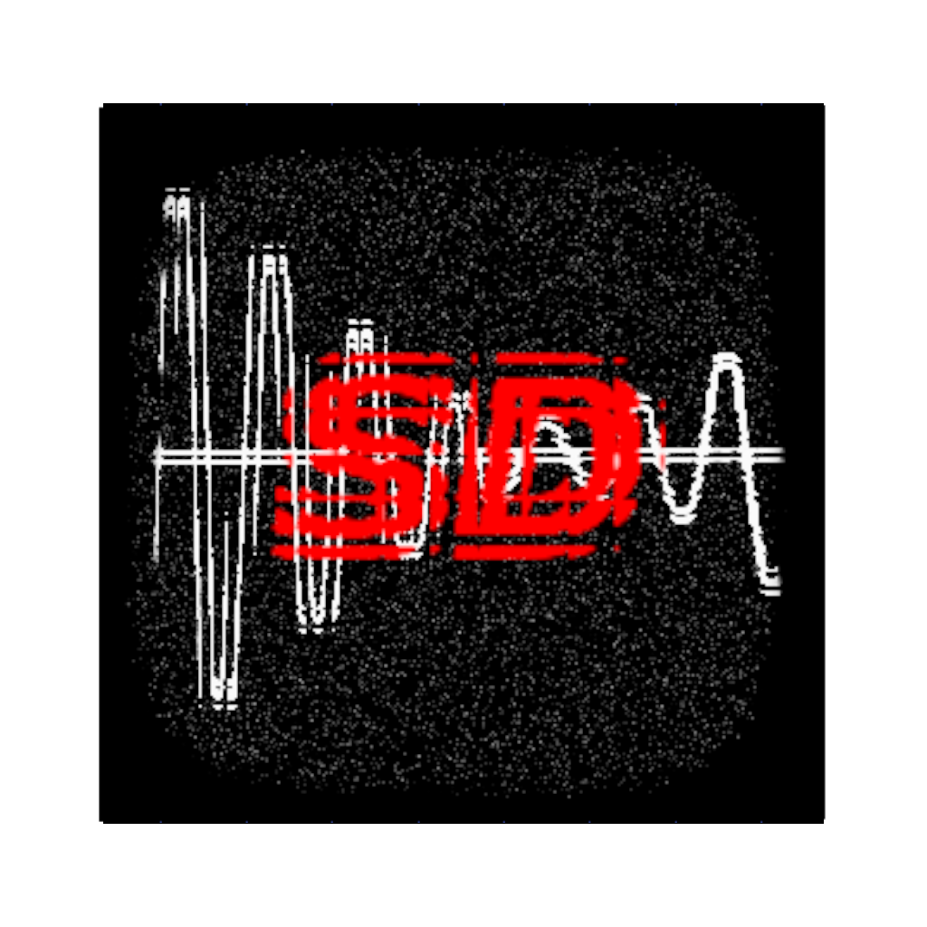

This document aims to explain and address topics related to how to operate the SD Plotter DB® software and the controller for data recording and process control.
We will start by installing the software.
By clicking on the installer icon this will be the first step:
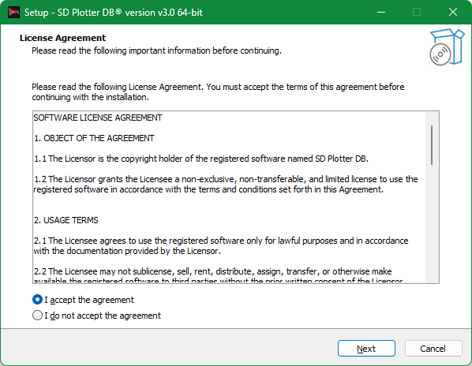

Click on next.
Here you can choose the folder where the software will be installed.
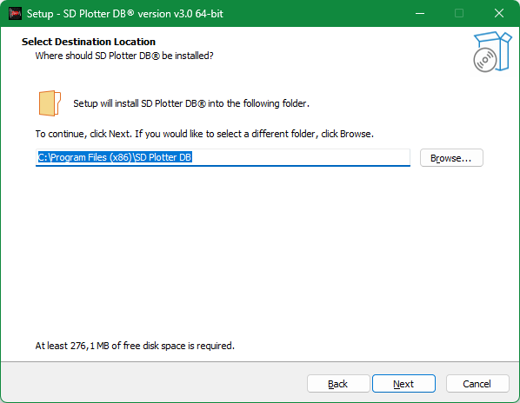

Click on next.
Check to have the installer create a desktop shortcut for the program.
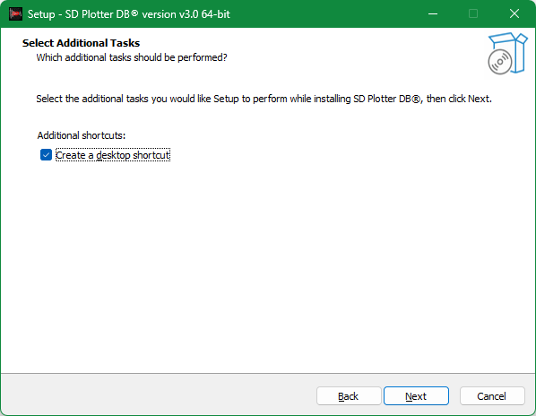

On this next screen, a summary of the installation parameters will be informed.

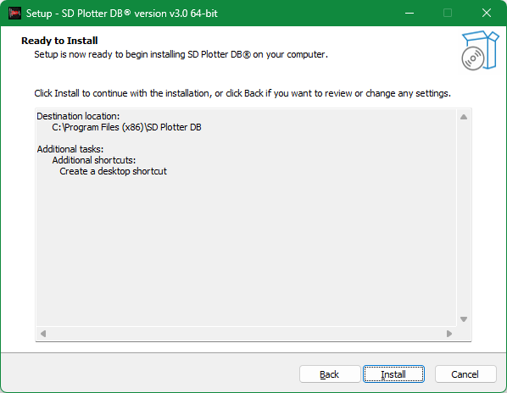

Click on next. If the program is already running and you are reinstalling it at the same time, this screen will appear. Close the program and continue the installation.
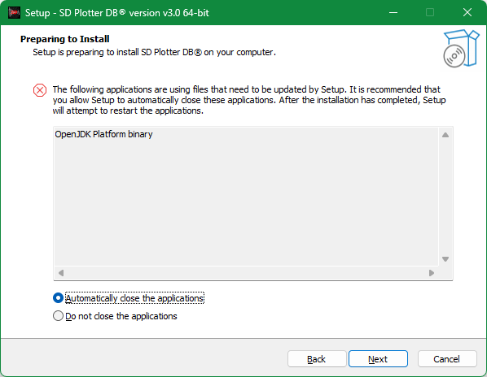

At this moment the system will be installing the files in the operating system.
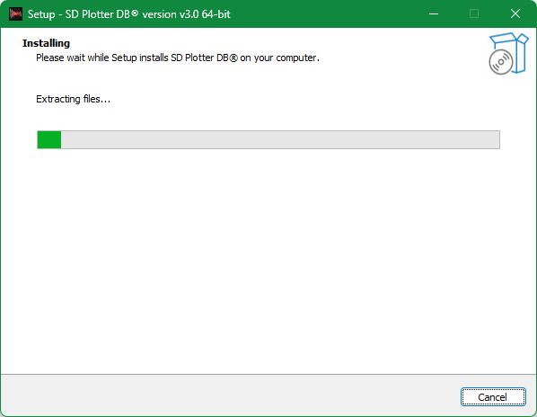

When the system finishes installing the files, this window will appear.
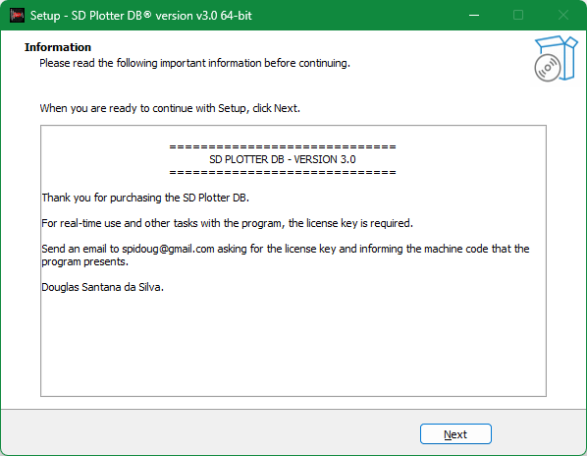

Click on next.

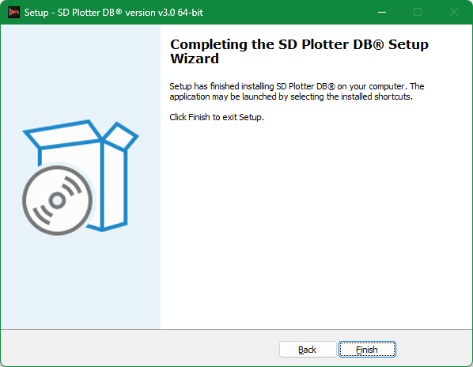

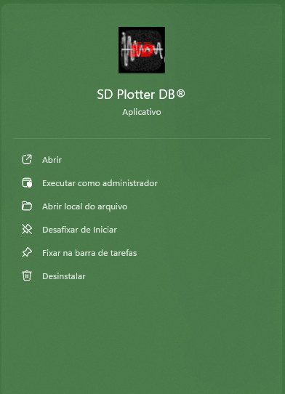
Open the program via the Windows start button or the desktop icon.

When starting the program, the following login screen will be displayed:

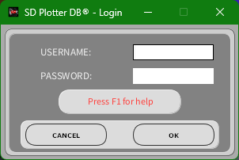

The default login for administrative access to the software will be:
USERNAME: Admin
PASSWORD: 12345

The Admin or a user with administrator privileges has the possibility of configuring sensor parameters, calibration, naming sensors, adding and deleting users.
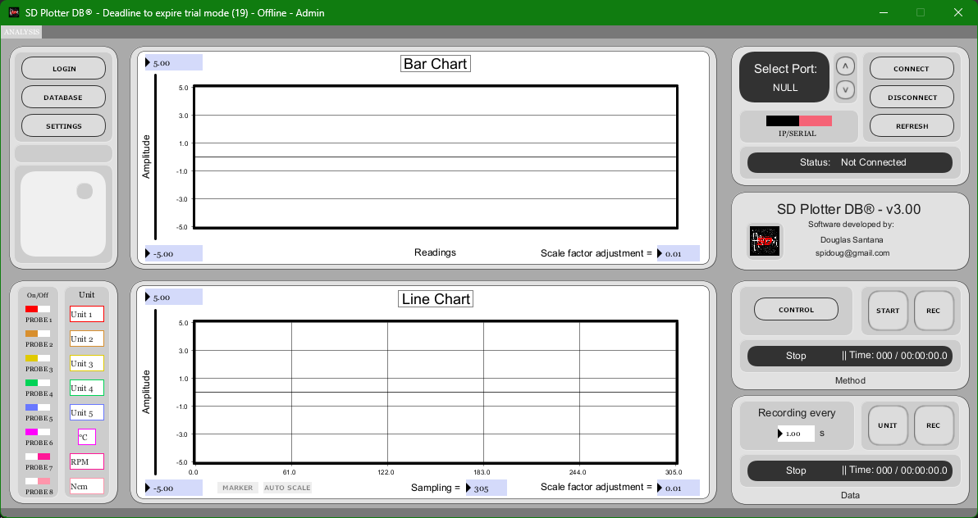

Admin can change the login password by creating the Admin user with a different password and can create other users with or without administrator privileges.
When launched for the first time, there will be a limit of 20 times of use.

When the installation is carried out and the software is started,

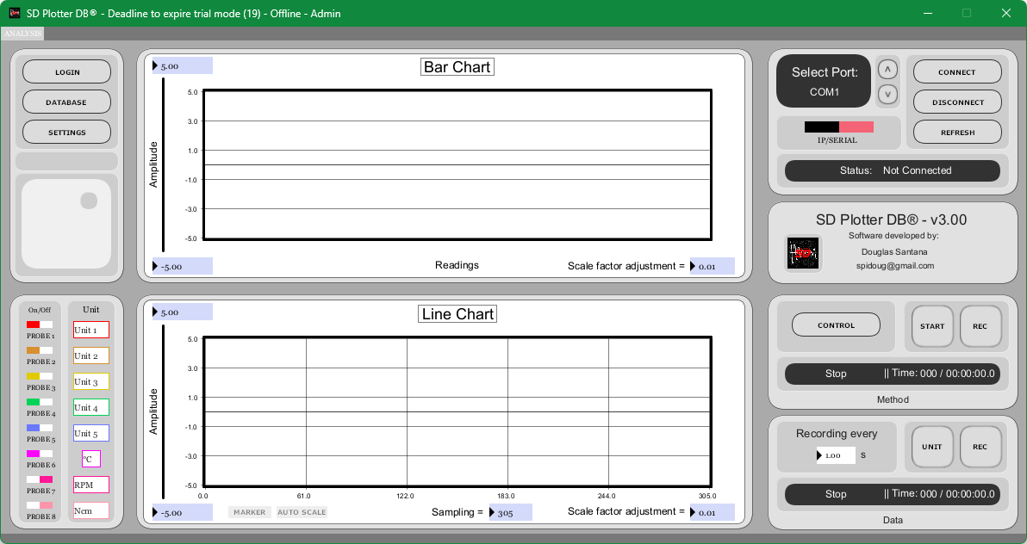

Click on the “SETTINGS” button.


The settings screen will open.
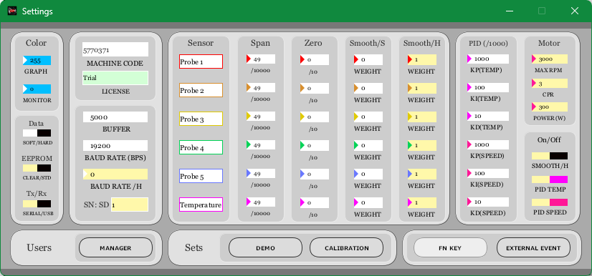


in the license field, insert the license referenced to the informed Machine code.

If the software has already passed the trial use period, the field to enter the license will turn yellow.
Contact us via spidoug@gmail.com and request the license informing the machine code that the software presents.

When opening the settings screen in calibration mode, the functions of sensor identification, span, zero, smooth S (software), smooth H (hardware), color adjustment and motor parameters will be available for editing only to Users with access privileges. administrator.

From this point, the software operation explanation will be for the calibration mode. Click the “CALIBRATION” button.
When the software is in calibration mode, login is not possible.
Then, when you have finished all necessary calibration procedures, close the software and open it again. This procedure is necessary, as auto scale systems are disabled in calibration mode.
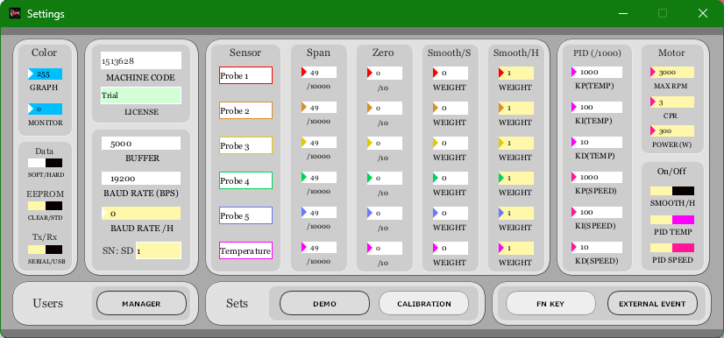

The moment the software enters calibration mode, two new buttons will be displayed on the main screen: “EEPROM” and “HEX”.
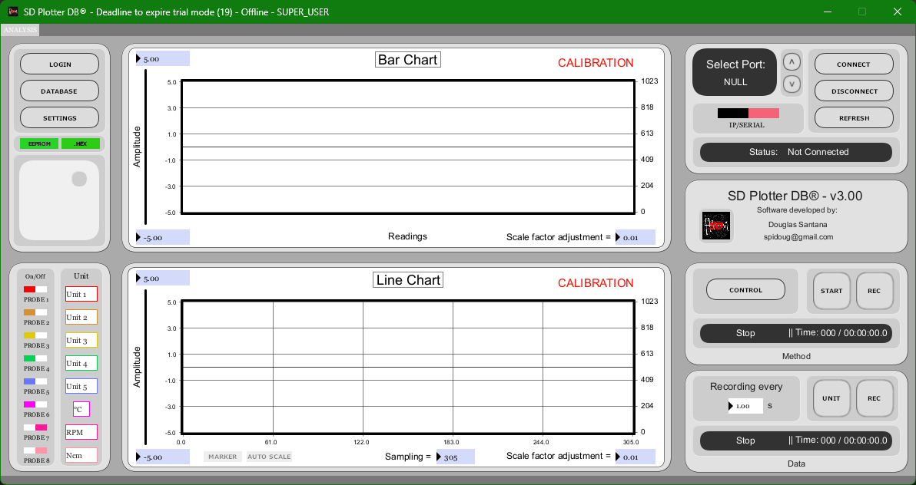

The connection between the equipment and the software is made via a serial connection or LAN network. Searching, connecting and disconnecting occurs through this panel.
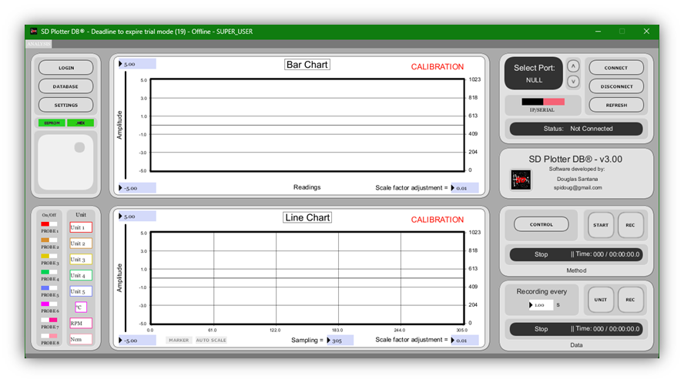

Firmware loading to the device only occurs via serial mode. Before recording the SD Plotter DB firmware, it is recommended to record the program for erasing the EEPROM memory.


The “HEX” button has the function of defining the firmware recording into the used hardware (Arduino flash memory).

To perform firmware recording or the EEPROM memory cleaning program, press the “HEX” button, with the Arduino connected to the computer and with the drivers already installed.

In the "SETTINGS" window, click the EEPROM button and click to the "CLEAR" position.
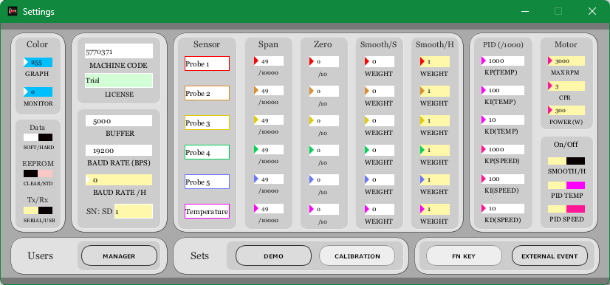

Return to the main screen and click on connect with the com port already selected for the installed equipment. If you give up writing program data for cleaning EEPROM memory, writing firmware, or writing data to EEPROM, press “DISCONNECT” before connecting and the actions will be undone.
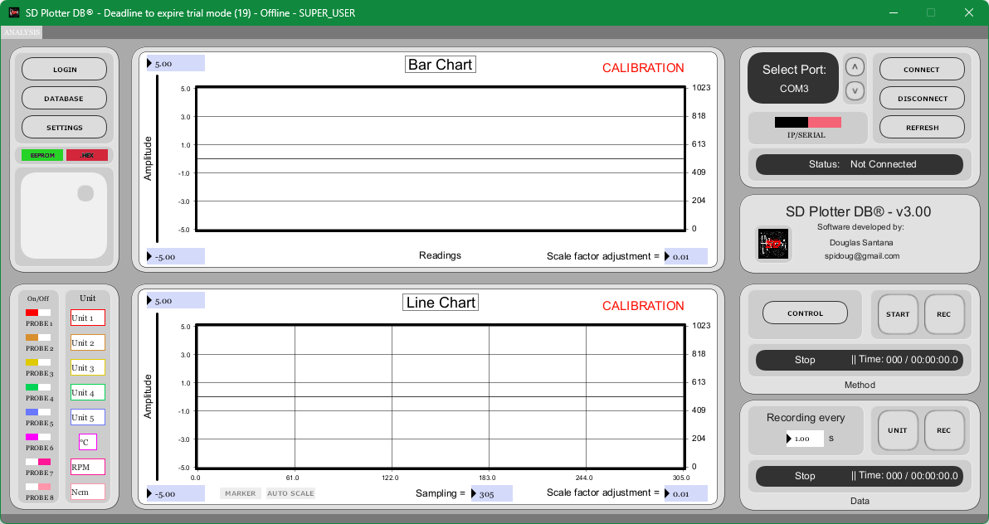

When starting to record program data for cleaning the EEPROM, the following screen will be displayed.
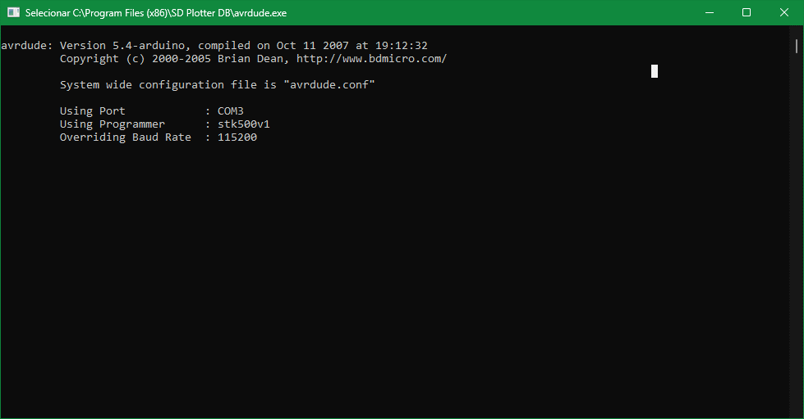

To write the firmware to the equipment, follow the previous step, but keep the "EEPROM" button in the "STD" position.


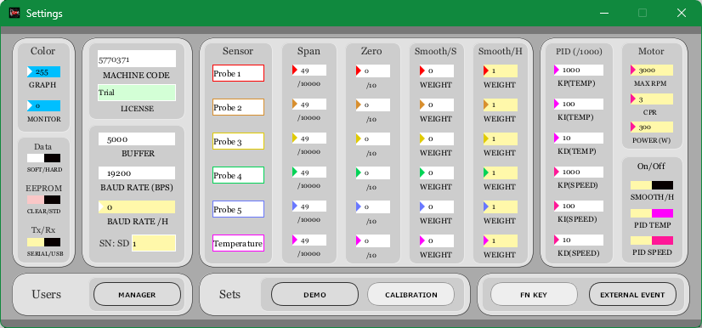

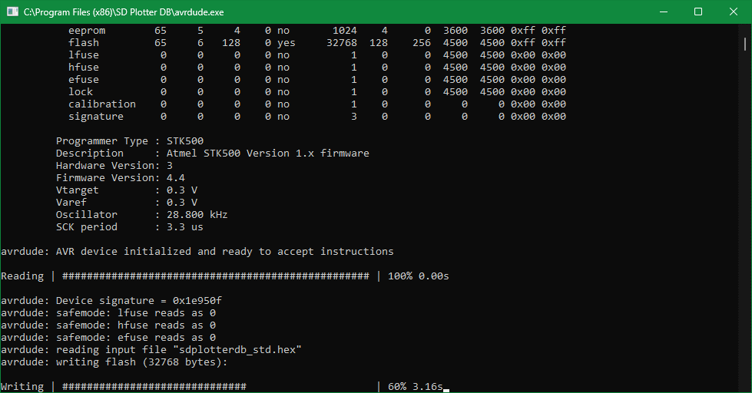
When starting the firmware recording procedure, the following screen will be displayed.

It is possible to work with SD Plotter DB for 3 types of Arduinos. By default, the firmware recorded will be for the Arduino UNO, if you want to change to Arduino Mega or Arduino nano, go to the program's root folder and change the settings through the file: "settings.txt".
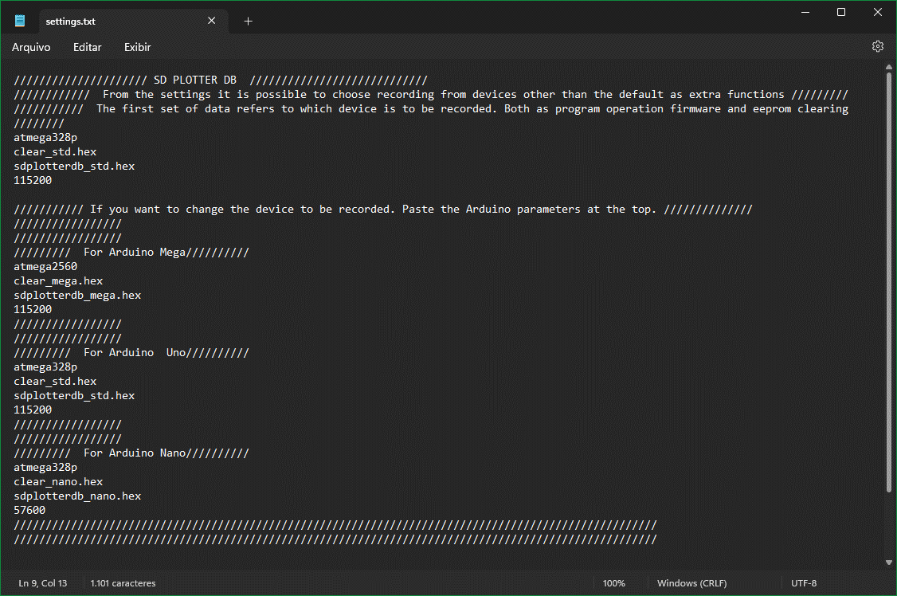

The hardware firmware is based on the following wiring diagram.
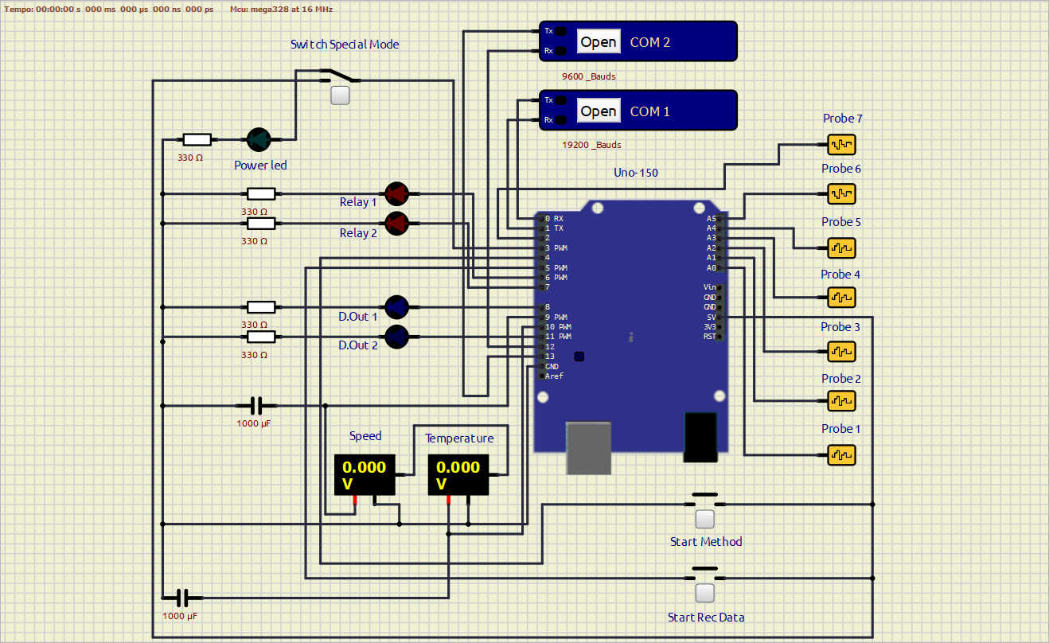
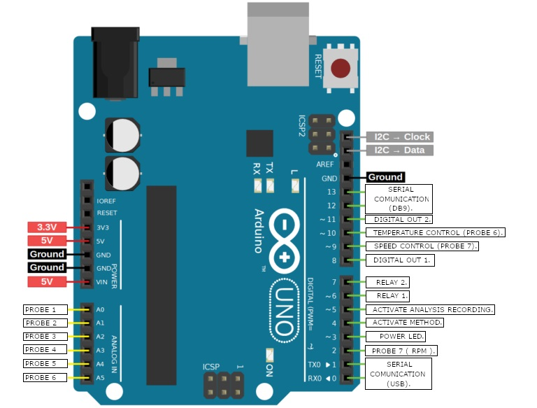
The pinout of this system is based on an Arduino UNO but can be used for Arduino NANO and Arduino MEGA.

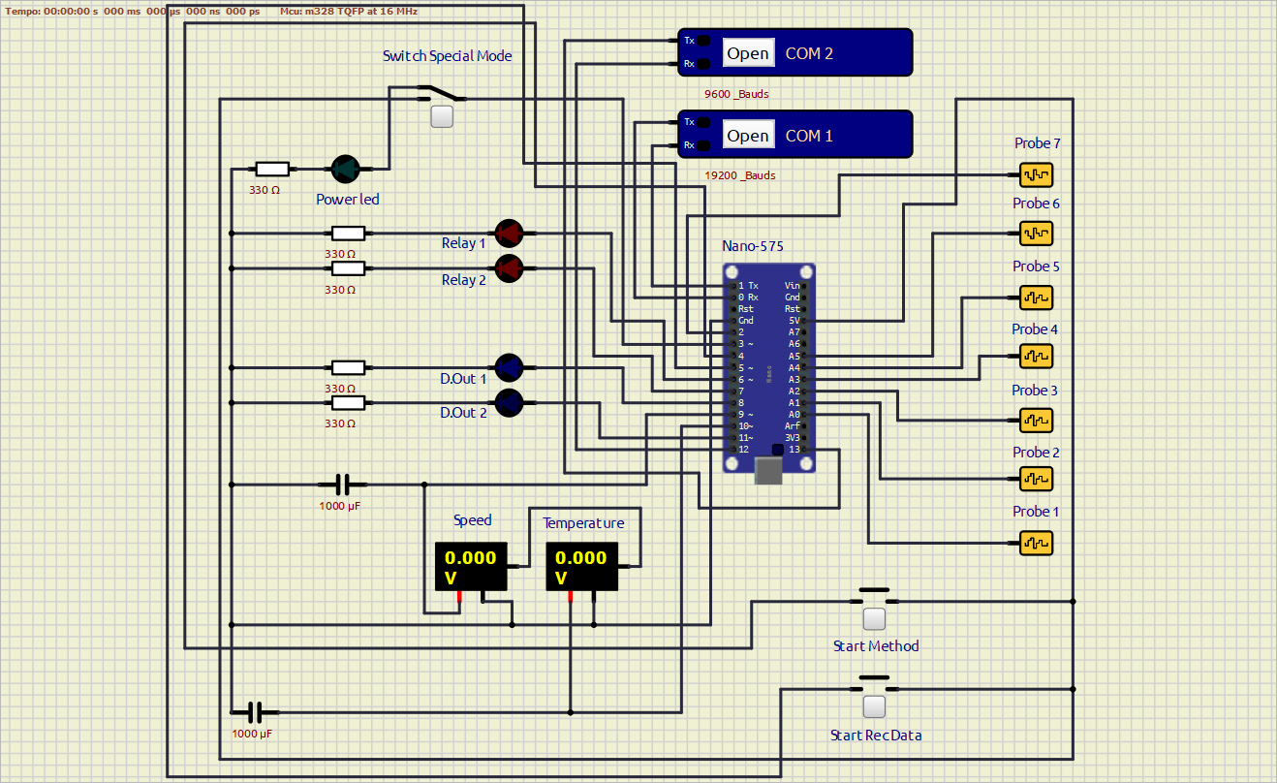
LAN communication is only implemented for the Arduino MEGA firmware. on Arduino MEGA, temperature control (PROBE 6) is on pin 11, speed control (PROBE 7) is on pin 12, Digital OUT 1 is on pin 8, Digital OUT 2 is on pin 9.
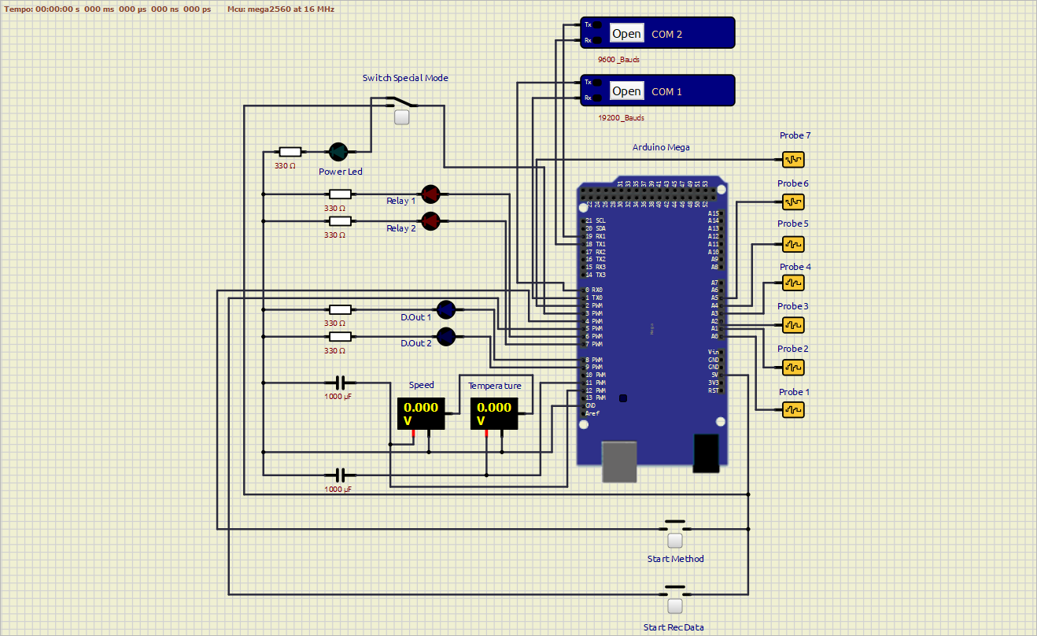

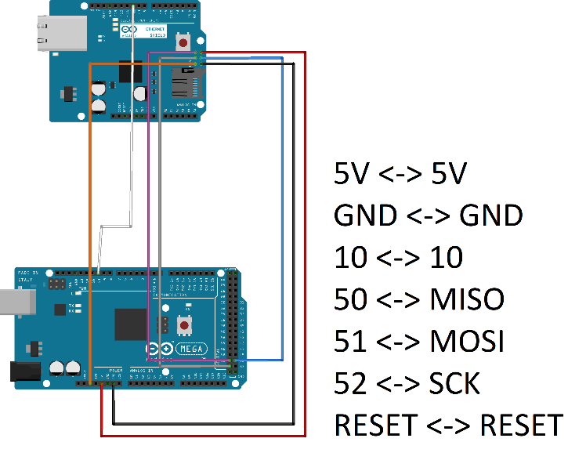

The EEPROM button has the function of defining the software for the function of recording parameters into the used hardware (Arduino EEPROM memory).

When pressing the “EEPROM” button on the main screen, the parameter fields that must be stored in the hardware will turn red, and some of them will be enabled for editing.

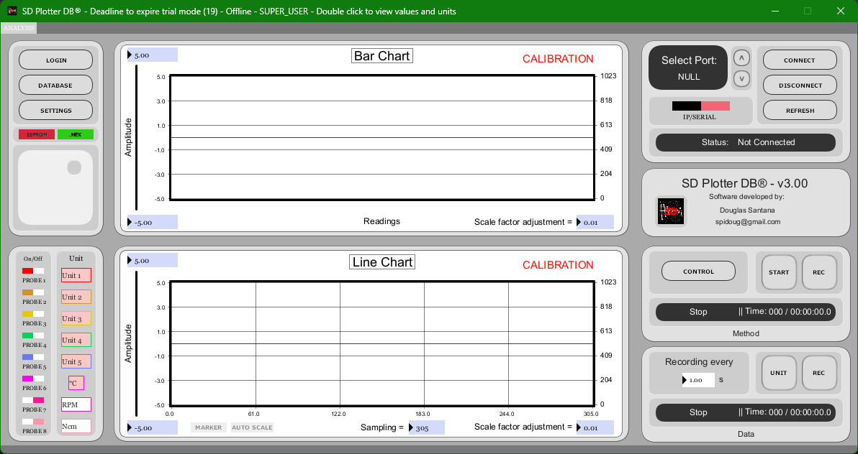

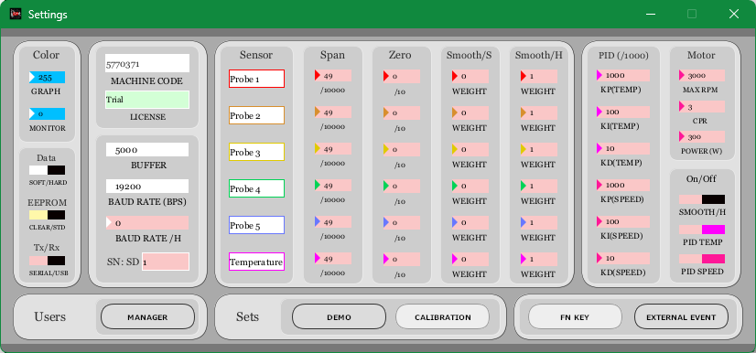

Once the parameters have been defined and you want to save them, press "CONNECT". If you give up saving the parameters, press "DISCONNECT".
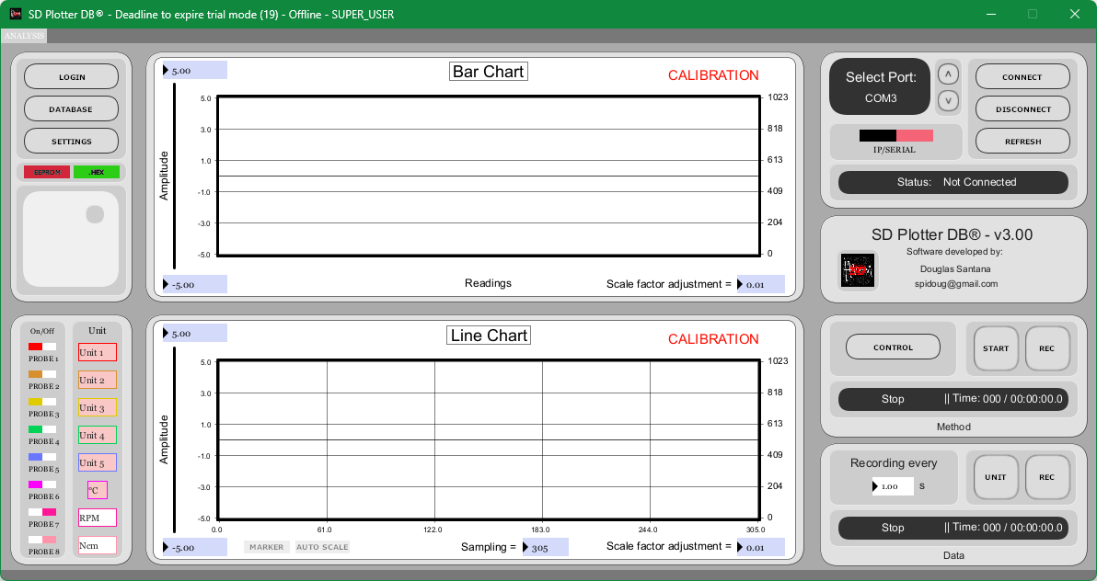

If everything goes well, the parameters will be saved, and the system will connect normally.

For the continuation of the next explanations, it is recommended to close the software and open it again for normal operation.

Once logged in as "Admin", we will begin the explanation of the program's features.

As an improved feature, the monitor function, when double-clicked on the center of the upper graph or pressed the FN10 button while connected to the system, enables or disables the window with the instantaneous values ​​of the processed signals.
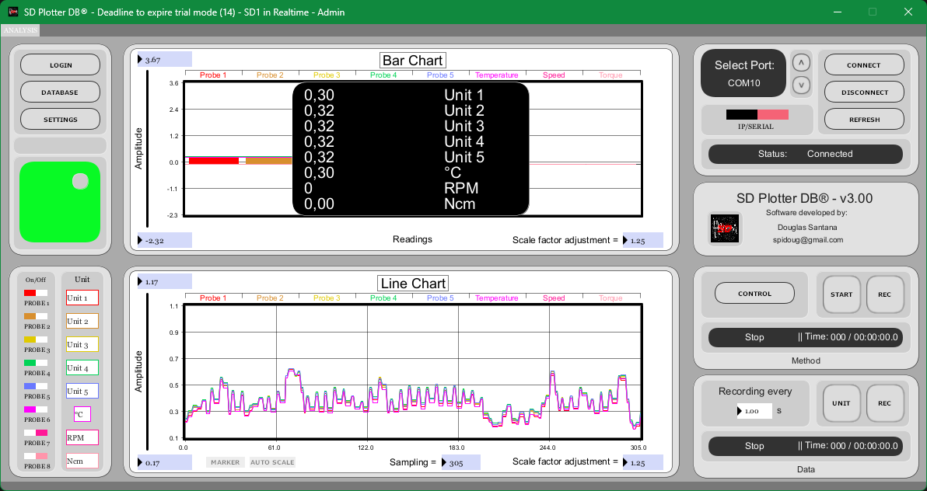

If you want to change the color of this window, click on "SETTINGS” and change the following field.

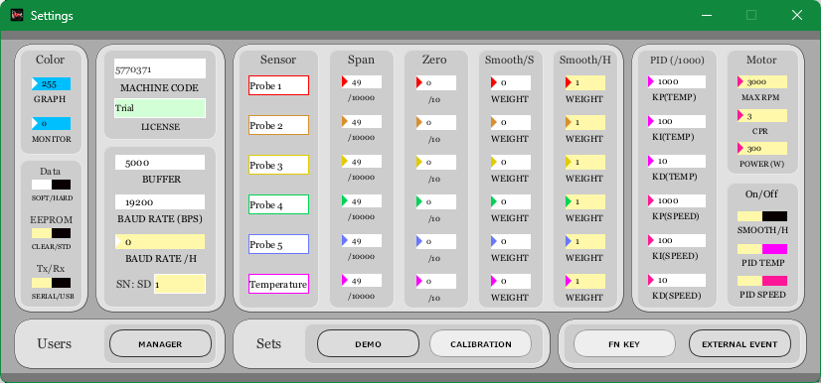

In the lower left part of the software, we can find the field to enable, disable, and name the units of the types of sensors connected to the system.


Activating or deactivating probe keys will interfere with the data being recorded.

The parameters of probes 1 to 6 can be recorded on the Arduino.

The marker button generates a cross on the time graph, allowing you to monitor the amplitude values ​​in relation to time. It also triggers the feature of tracking bar graph values ​​for each bar using a line connected to the y-axis.

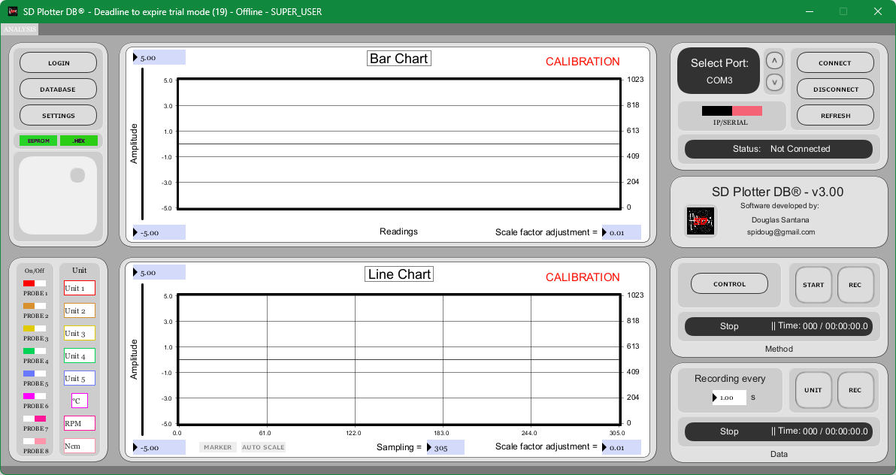

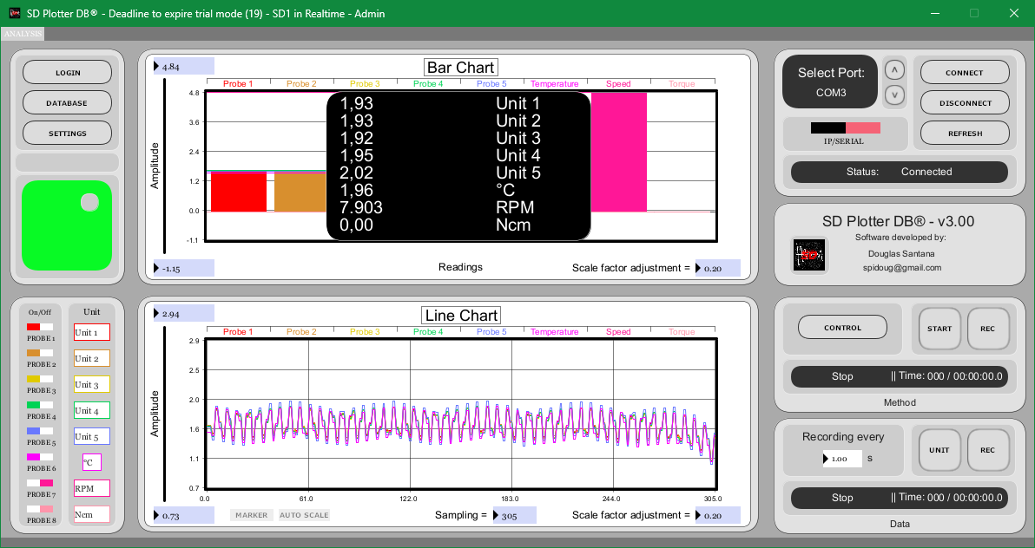
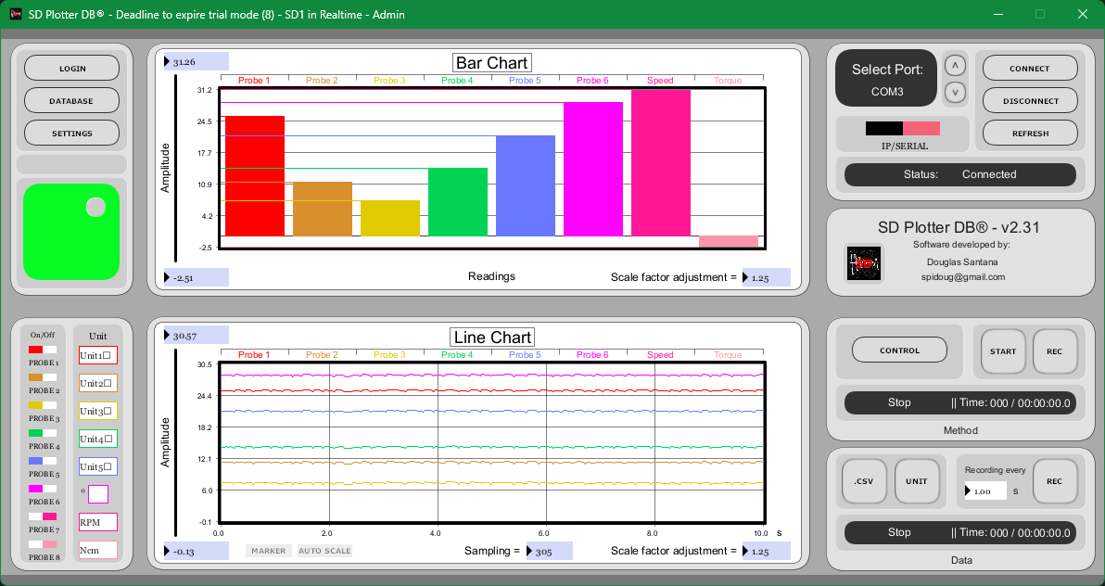
When the monitor function is not used, it is possible to monitor the graph by bars.
Before the connection is made, the sampling rate that will be used for the graph and data obtained must be chosen.
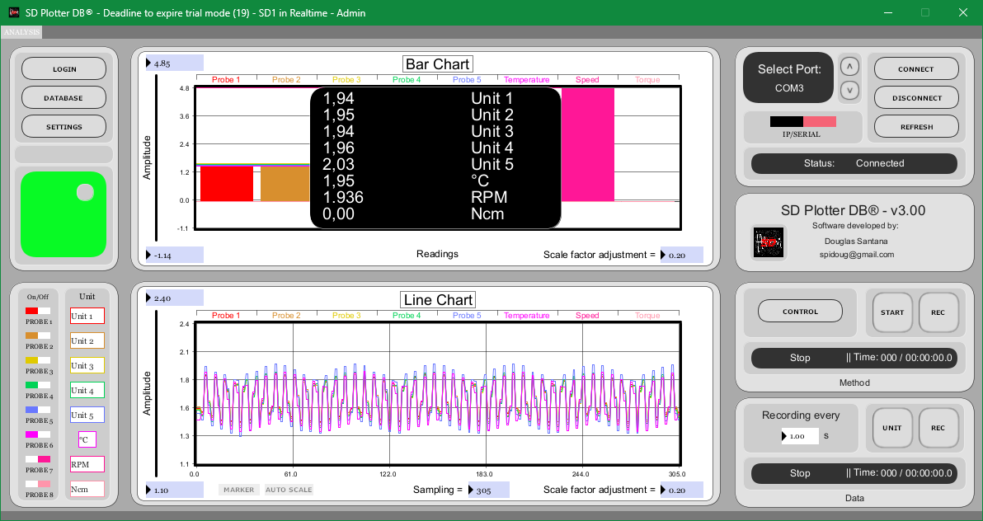
When there are no COM ports available on the computer, it will be reported as null in select port.

Once the connection has taken place, the sampling rate cannot be changed.

When you click on the database button, the following screen will open:
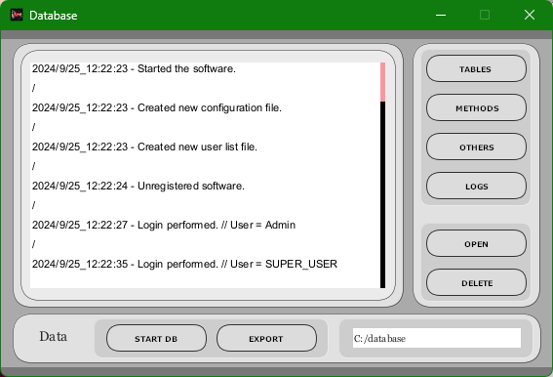


When opened, the system log area is displayed.

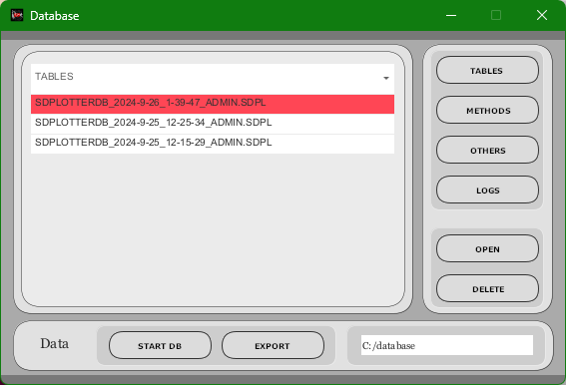
When pressing the "TABLES" button, the analysis data list will be displayed (CSV/TXT), which can be opened and/or deleted.

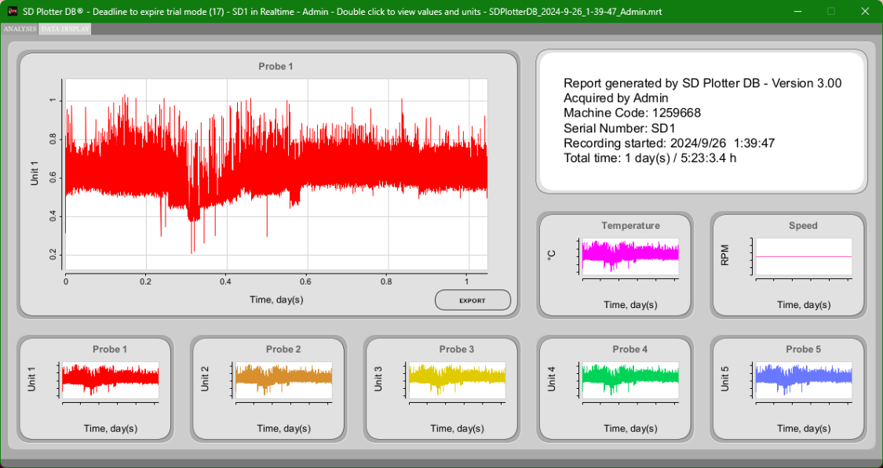
eIf you want to generate a snapshot of this window, double-click on the text box with the analysis data, or press “F8”.
When pressing the "EXPORT" button, the selected date file will be exported to a folder named "exported" in the root folder where the program will be installed. The file will be in .CSV structure.

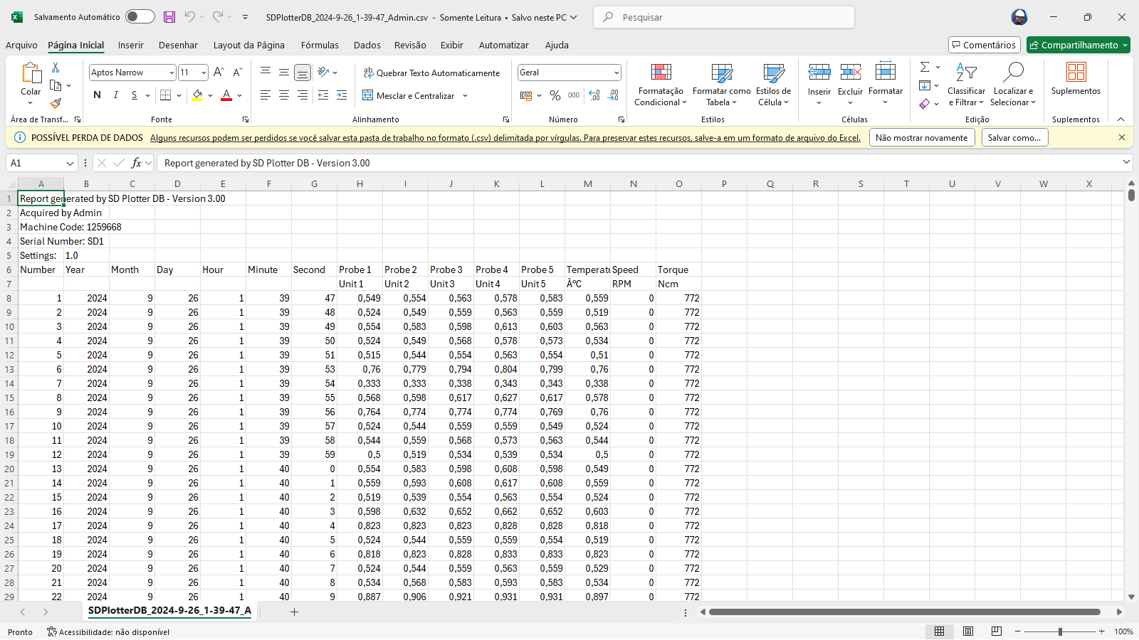

When pressing the "METHODS" button, the list of recording methods will be displayed, which can be reproduced and/or deleted.
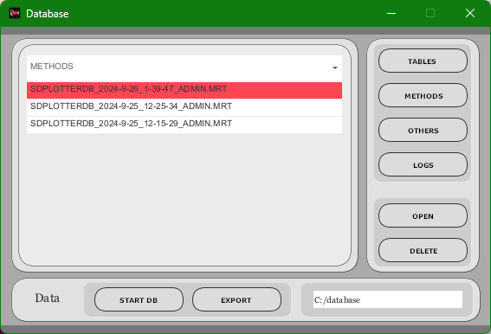

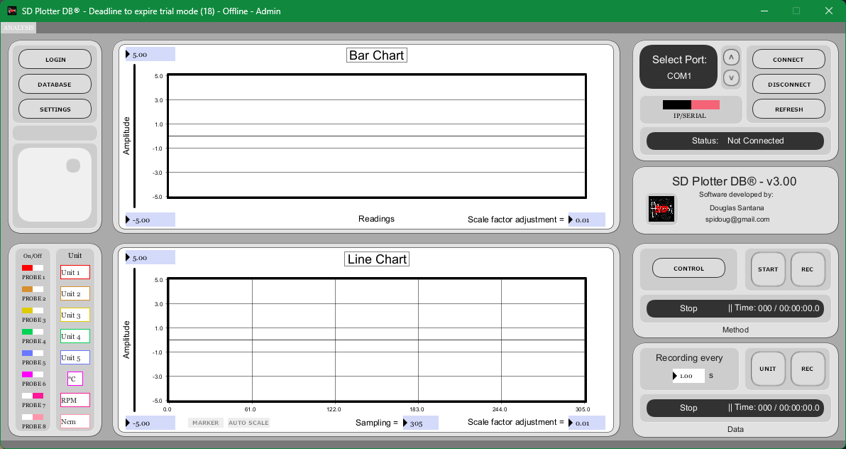
When pressing the "OTHERS" button, the list of snapshots generated when pressing the “HOME” button or double-clicking here will be displayed, which can be displayed and/or deleted.

Recording data files are available in the data folder located in the software installation folder.
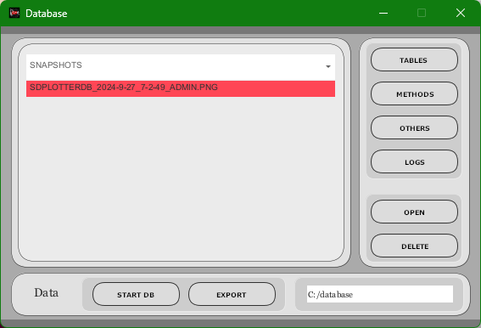

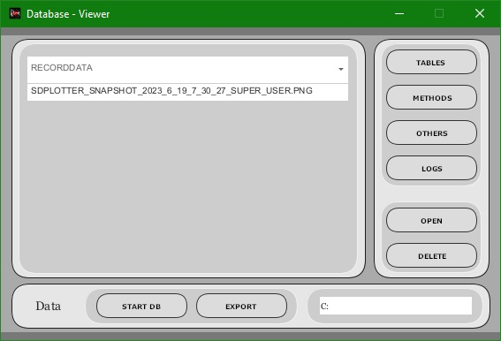
By pressing the “START DB” button when in calibration mode, a database will be started at the defined field location, this database will record analysis data, methods and a system log. When enabled, it will no longer be possible to disable or change the save location. The system will close and you will need to open it again.
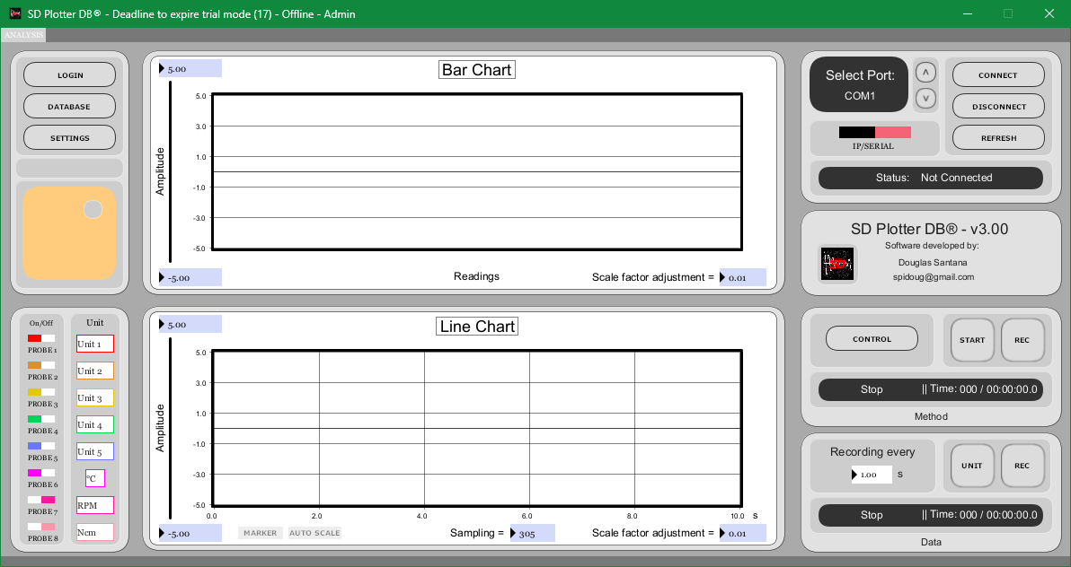

When pressing the "EXPORT" button, an instant folder of all the data present in the database will be generated.
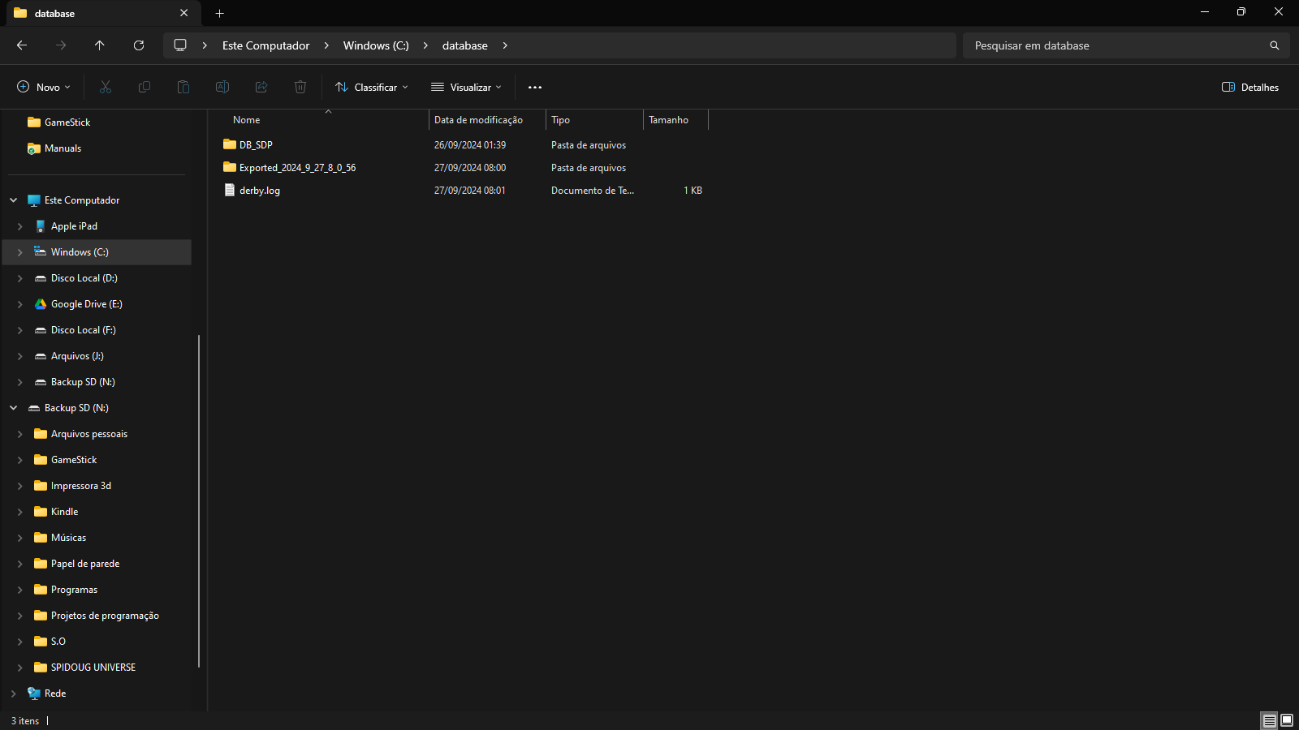

The “START DB” and “EXPORT” button can only be activated by an administrator and when the system is disconnected.

A database backup file can be put back in place and the software performs the reconnection.

When pressing the “CONTROL” button, the following screens will open.



The "CONTROL" screen displays controls over the actuators and parameters of how they will act in the method to be recorded, or when played back from a method.

“PROBE 6”, “PROBE 7”, “D.OUT 1”, “D.OUT 2” are functions that can be recorded and played back. “RELAY 1” and “RELAY 2” are set instantly.
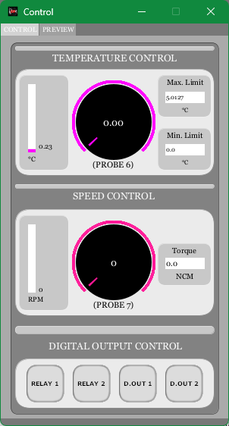

It is possible to observe the behavior of each of the actuators over time.
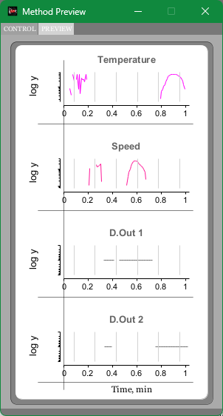
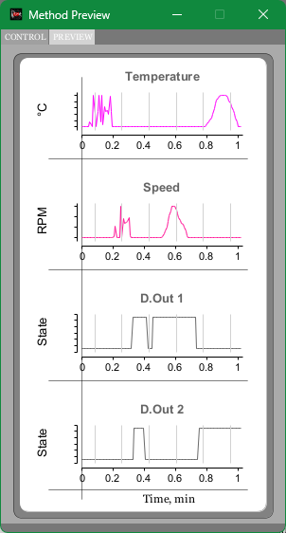
When the method is playing, there is a guide indicating the position in relation to time.

When a method is very long and there are few actuator variations, it can be difficult to evaluate reproducibility. By pressing the "ENTER" button, or clicking on the screen, it is possible to switch the graphs to a logarithmic scale, allowing you to better follow the method.

The “CONDITION” screen shows the controls and actuation of “RELAY 1” and “RELAY 2” when the value of a probe reaches the established condition. This screen is activated when the system is in calibration mode and the "CONTROL" button is pressed.
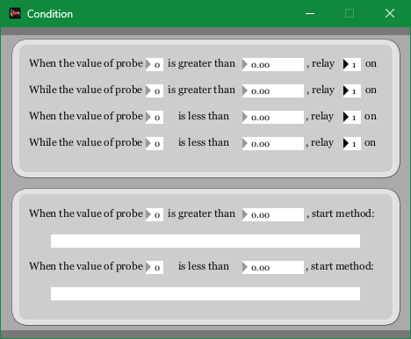

You can choose up to 2 methods to be reproduced according to the prepared condition. The chosen methods can be played from any folder, there is no impediment from different users.
Methods from other users/folders can be inserted for activation by condition.

If you double-click the method identification area, the method loaded in the opened instance will be inserted.


We will return to the "SETTINGS" screen.

The "DATA" button refers to the parameters used to be obtained from the Arduino memory or saved on the PC itself.
The "Tx/Rx" button refers to communication between Arduino and PC, being carried out via the Arduino's standard USB port, or the emulated Serial port.
The "BUFFER" field changes automatically when changing "BAUD RATE/H".
The "BAUD RATE/S" field is automatically changed when "BAUD RATE/H" is modified. If the Arduino has already been recorded with a baud rate without the software having recorded it, it must be changed manually.
The "BAUD RATE / H" field refers to the communication speed that the Arduino will maintain. The parameter has 4 modes:
0 = 19200 bps
1 = 38400 bps
2 = 57600 bps
3 = 115200 bps
The "SN SD" field refers to the equipment identification.
The "SENSOR" field refers to the names that will be given to the sensors connected to the system.
The "SPAN" and "ZERO" fields refer to the configuration used to create the linear function to be used in plotting the signal from each sensor.
The "SMOOTH/S" field refers to the signal smoothing setting for each sensor, calculated by the software.
The "SMOOTH/H" field refers to the signal smoothing setting for each sensor, calculated by Arduino. This smoothing is only activated when the "SMOOTH/H" button is in the "ON" position.
The “PID” field refers to proportional, integral and derivative control, used in temperature and speed control. These controls are instantaneous while the system is on and can be modified by a user with administrator privileges. The PID controls on the actuators will only be active when their respective activation buttons are in the "ON" position.
In the "MOTOR" field, there are 3 parameters to be entered.
Maximum speed of the motor installed in the system.
CPR, Number of pulses detected by an encoder in one revolution of the motor.
And the last parameter will be the engine power in Watts, for torque capacity.

The "EXTERNAL EVENT" button enables or disables the Arduino control signal receiving functions to activate data recording and method playback.

The "FN KEY" button activates or deactivates the function activation shortcut keys for all program windows.

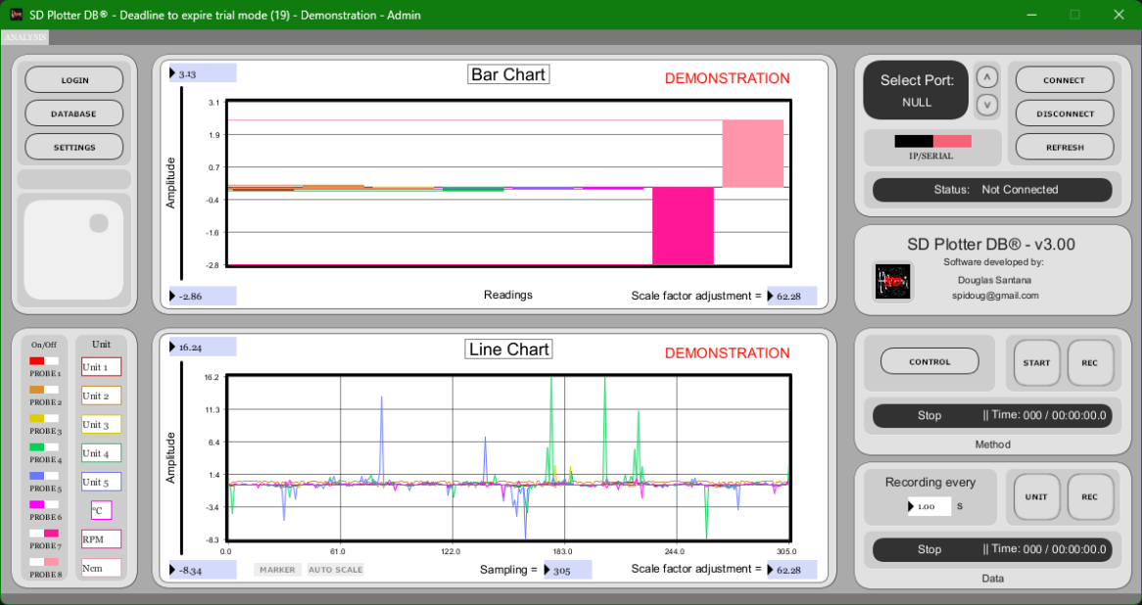
The "DEMO" button activates or deactivates the sensor signal simulation mode.

When pressing the "MANAGER" button when the user has administrator permission, the system will display the screen for creating users.

The software can be authenticated in two ways: Through users registered in the program's database, or through the Windows authentication feature. If you want Windows authentication, click on the "Windows" icon and press "OK". Once activated, it will no longer be possible to reverse this action.

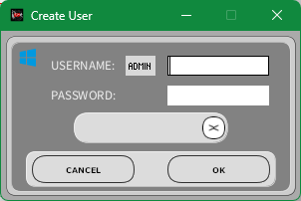

If you choose to authenticate through the program, it is possible to create users with or without administrator privileges using the "ADMIN" button.

If you want to delete a user from the program's database, click on the "X" button and choose the user to be deleted. The Admin user cannot be deleted.

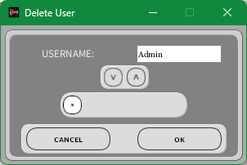

In the SD Plotter DB program, we will connect with the COM port, referring to the Arduino USB input. In the Arduino IDE, we will open the serial monitor through the COM port referring to the serial connection created (9600 – baud rate).

On the "SETTINGS" screen, modify "Tx/Rx" for the port of interest.
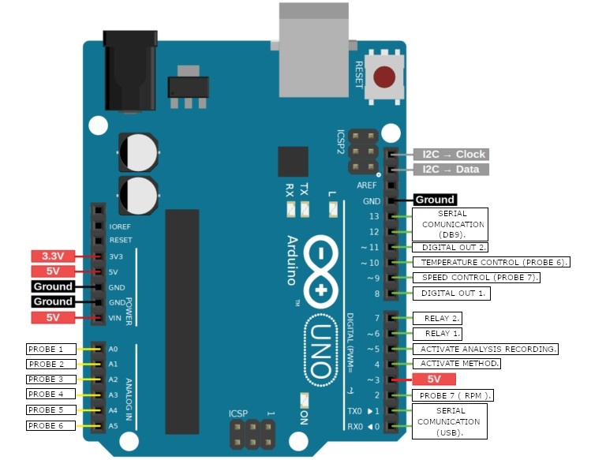

PIN 3 - > to Vcc. 5V

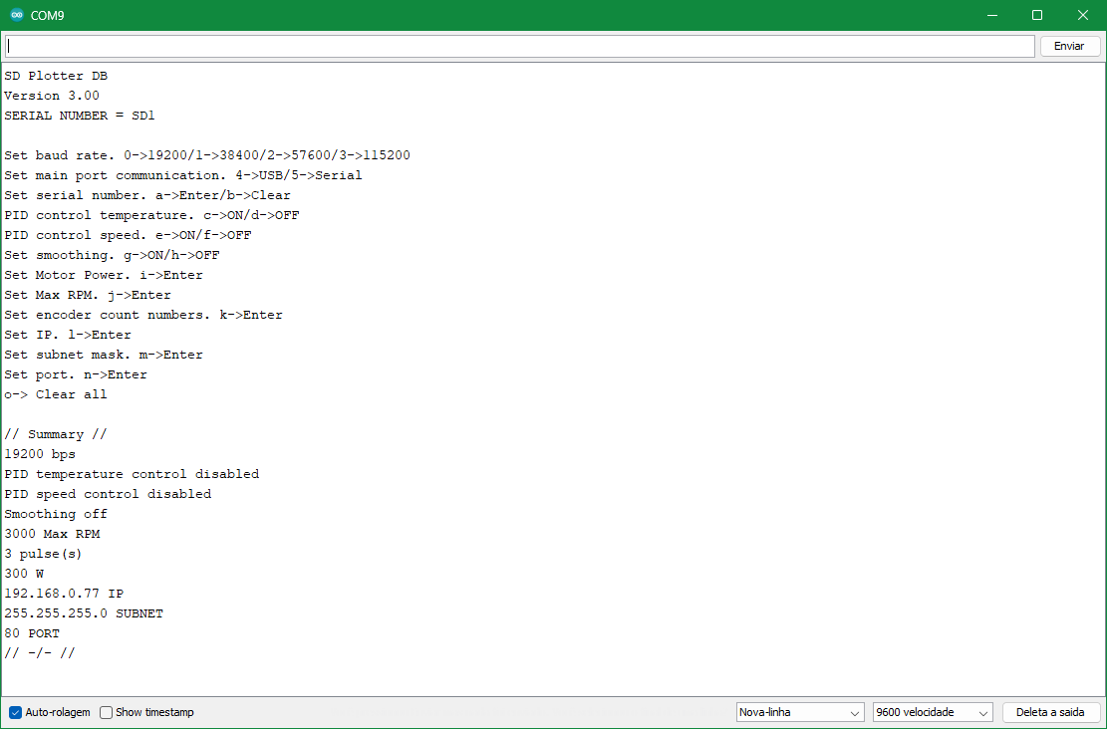
The following configuration screen will appear:

So that command values ​​such as "SERIAL NUMBER", "MOTOR POWER", "MAX RPM", "ENCODER COUNT NUMBERS", *“IP”, *“SUBNET”, *“PORT” can be inserted. the SD Plotter DB software must be connected to the device through the other port, and through the "SETTINGS" window, in the PID field, the values ​​can be defined.
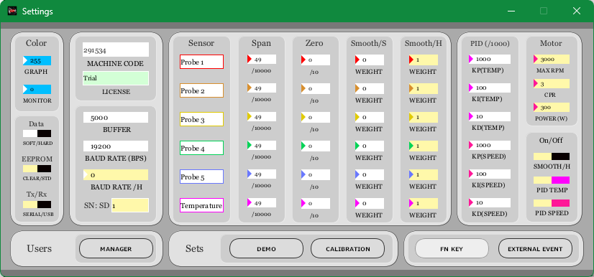
Confirmation of the values ​​for the commands will be done through the KP(TEMP) field.

It is recommended that the USB power suspension is disabled so that communication is not interrupted at any time.
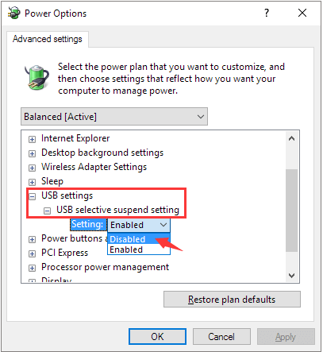

When the system is configured for IP communication, the following parameters will be displayed in place of "BUFFER", "BAUD RATE (bps)" and "BAUD RATE / H":
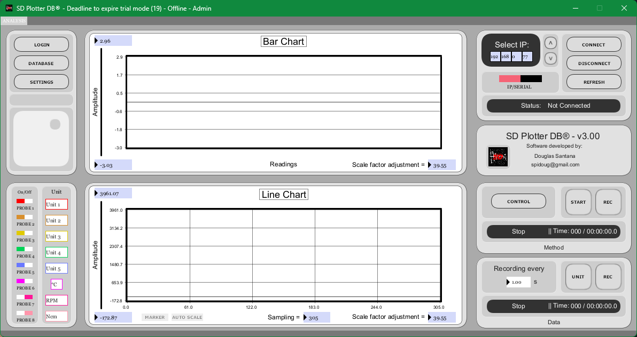

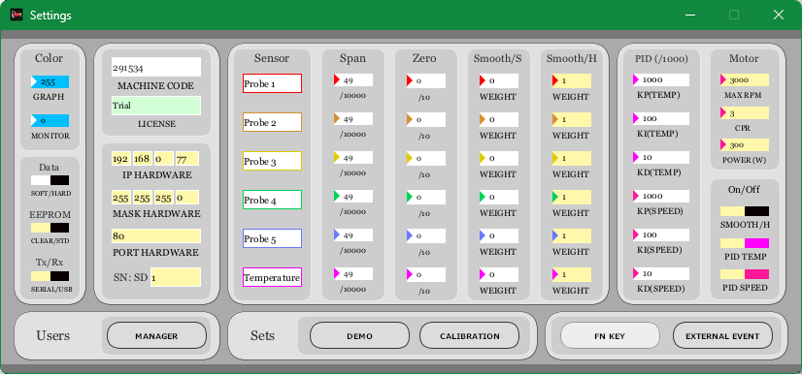
When connecting via IP, your system's default browser will open to the address related to the IP field and will be presented on the next screen.

On this screen it is possible to monitor the values ​​of each probe, test the relay ports and digital outputs by switching every 1 second, evaluate the recording start and method start ports.

Using the "Start Record" and "Stop Record" buttons it is possible to record data via the browser page. Generating a download file that looks like this:

*For Arduino Mega.
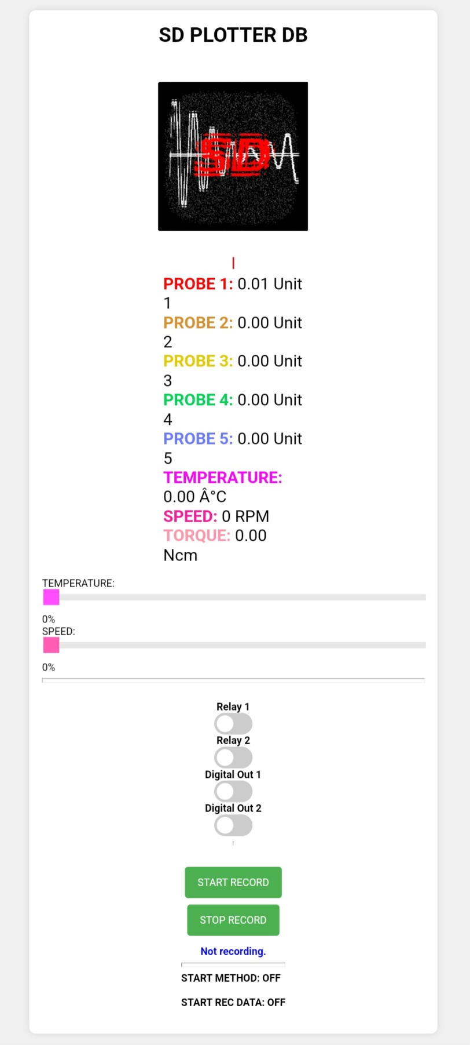
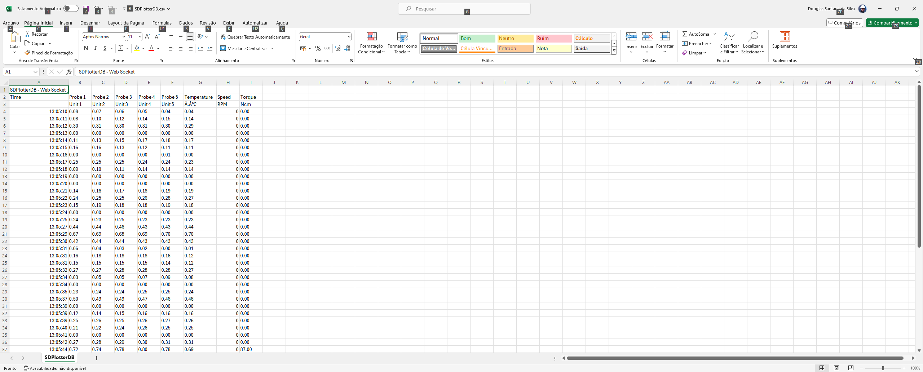

Keyboard commands

To paste some text into a field in the software, use the following keys: "Alt' + "v".

-LOGIN

“ESC” - Cancel the action.
“ENTER” - Press the "OK" button.
“LEFT” / “RIGHT” = “UP” / “DOWN” - Scroll through the names in the user list (deletion mode).
“F1” - Open manual.
“F2” - Configure for Windows authentication (creation mode).
“F3” - Enables or disables admin configuration for user (creation mode).
“F12” - Change between the user creation and deletion tabs.

-ANALYSIS

“ESC” - If connected and not recording method or data, or playing method, it will disconnect the program.
“ENTER” - Connects the system via serial communication.
“UP” / “DOWN” - Increases or reduces the time rate value for data recording.
“LEFT” / “RIGHT” - Increases or reduces the sample rate value of the line chart.
“PAGE UP” /” PAGE DOWN” - Move up or down the serial ports list.
"Alt' + “0” - Changes communication between LAN or Serial.
"Alt' + “1” / “2” / “3” / “4” / “5” / “6” / “7” / “8” - Enable or disable probe preview.
“HOME” - Take a snapshot.


“F1” - Open manual.

Double-clicking the icon opens the manual.

“F2” - Start recording analysis data.
“F3” - Start method reproduction.
“F4” - Start recording method.
“F5” - Perform "LOGIN". / Enable EEPROM recording mode.
“F6”- Open "DATABASE" screen.
“F7”- Open "SETTINGS" screen.
“F8” - Open "CONTROL" screen.
“F9” - Command for graphical scale normalization. / Enable firmware recording mode.
“F10” - Update list of serial ports.
“F11” - Enable or disable "MONITOR".
“F12” - Switching between the Analysis and Display tabs.
-DISPLAY

“SPACE” - Performs auto scaling on the active graph.
"Alt' + “1” / “2” / “3” / “4” / “5” / “6” / “7” / “8” - Choose the graph to be displayed.
“UP” / “DOWN” - Enlarges or reduces the graph scale on the Y axis but maintains the X axis (time) scale.
“LEFT” / “RIGHT” - Move the graph forward or backward.
“HOME” - Take a snapshot.
“PAGE UP” /” PAGE DOWN” - Move up or down in the list of displayed data.
“F1” - Open manual.
“F2” - Export data in .CSV format.
“F12” - Switching between the Analysis and Display tabs.

-DATABASE

“ENTER” - Open files.
“DELETE” - Delete files.
“UP” / “DOWN” - Go through the file list for each tab.
“F1” - Open manual.
“F2” - Start the database.
“F3” - Generates database export.
“F5” - Open the "TABLES" tab.
“F6” - Open the "METHODS" tab.
“F7” - Open the "OTHERS" tab.
“F8” - Open the "LOG" tab.

-SETTINGS

“F1” - Open manual.
“F2” - Write firmware or erase to EEPROM.
“F3” - Change communication input via serial or USB port.
“F4” - Open "MANAGER" screen.
“F5” - Run signal demonstration.
“F6” - Run calibration mode.
“F7” - Activate or deactivate special key commands.
“F8” - Activate or deactivate data recording and method reproduction by external command.
“F9” - Use parameters recorded by Arduino or software.
“F10” - Enable or disable data smoothing.
“F11” - Enable or disable PID control for temperature.
“F12” - Enable or disable PID control for speed.

-CONTROL

“LEFT” / “RIGHT” - Change probe 6 controls.
“UP” / “DOWN” - Change engine speed.
“F1” - Open manual.
“F2” - Start recording analysis data.
“F3” - Start method reproduction.
“F4” - Start recording method.
“F5”- Enable or disable Relay 1
“F6”- Enable or disable Relay 2
“F7”- Enable or disable Digital OUT 1
“F8”- Enable or disable Digital OUT 2
“F12” - Switching between the Control and Preview tabs.

-PREVIEW

“ENTER” - Enables or disables visualization of graphs in logarithmic format.
“PAGE UP” /” PAGE DOWN” - Move up or down in the list of displayed methods.
“F1” - Open manual.
“F12” - Switching between the Control and Preview tabs.

This project was idealized by the following academic course conclusion work:
https://publicacoes.even3.com.br/tcc/desenvolvimento-de-um-registrador-de-dados-aplicado-no-monitoramento-e-controle-de-atuadores-para-uso-em-processos-quimicos-1368024

Instruction manual produced by Douglas Santana

spidoug@gmail.com

